How to make a normalization rule which will move M and text after M in subfield h to subfield i in field 852 | 
Note: If you copy and paste make sure the quotation marks remain correctly

Example one

This will show how to make a normalization rule which will change
852 0 $$b UL $$c ul $$h PS3570.H56M7
To
852 0 $$b UL $$c ul $$h PS3570.H56 $$i M7

Or in other words:

Any time M (capital M) appears in 852 subfield h put it in subfield i together with whatever is after the M

Note that in case above in the source record there is no space before the M

rule "change M in subfield h to separator_M"
priority 3
when
not exists "852.i.*"
then
replaceContents "852.h.M" with "separator_M"
end

rule "splitSubField"
priority 2
when
not exists "852.i.*"
then
splitSubField "852.h.separator_"
end

rule "change duplicate subfield"
priority 1
when
not exists "852.i.*"
then
changeSubFieldExceptFirst "852.h" to "i"
end

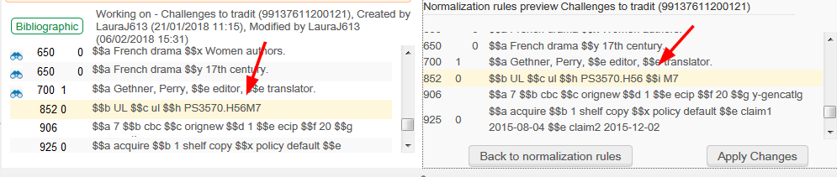

Example two

This will show how to make a normalization rule which will change
852 0 $$b UL $$c ul $$h PS3570.H56 M7
To
852 0 $$b UL $$c ul $$h PS3570.H56 $$i M7

Or in other words:

Any time space M (capital M) appears in 852 subfield h put it in subfield i together with whatever is after the M

Note that in case above in the source record there is a space before the M

rule "change M in subfield h to separator_M"
#
# Note that actions stipulated in the rule with the higher priority are performed first.
# For example, the action in the rule with priority 2 below is performed before the action in the rule with priority 1
#
# change 852 0 $$b UL $$c ul $$h PS3570.H56 M7
# To
# 852 0 $$b UL $$c ul $$h PS3570.H56 $$i M7
#
priority 3
when
not exists "852.i.*"
then
replaceContents "852.h. M" with "separator_M"
end

rule "splitSubField"
priority 2
when
not exists "852.i.*"
then
splitSubField "852.h.separator_"
end

rule "change duplicate subfield"
priority 1
when
not exists "852.i.*"
then
changeSubFieldExceptFirst "852.h" to "i"
end

